ADMIN TASK OF THIS WEEK

1.Login Screen

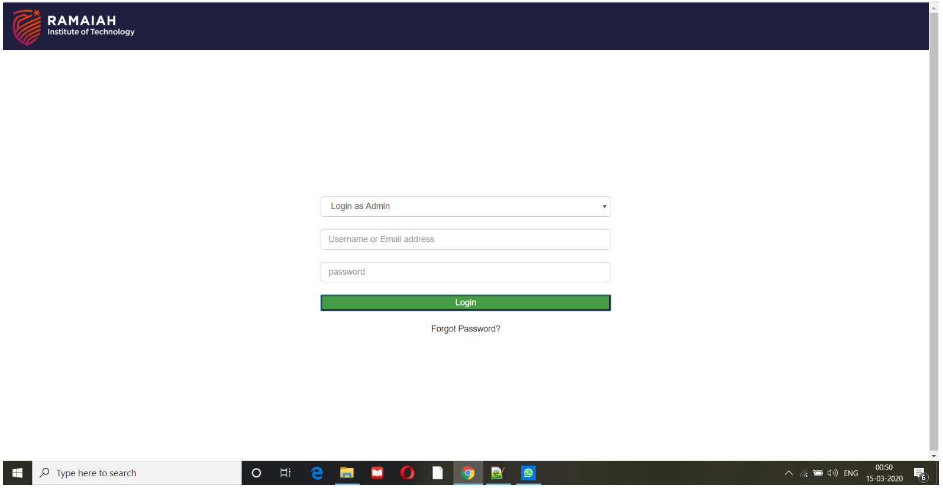

\*Login screen created

\*Options for entering username and password

\*Forgot password option Provided

2. ADD Faculty page

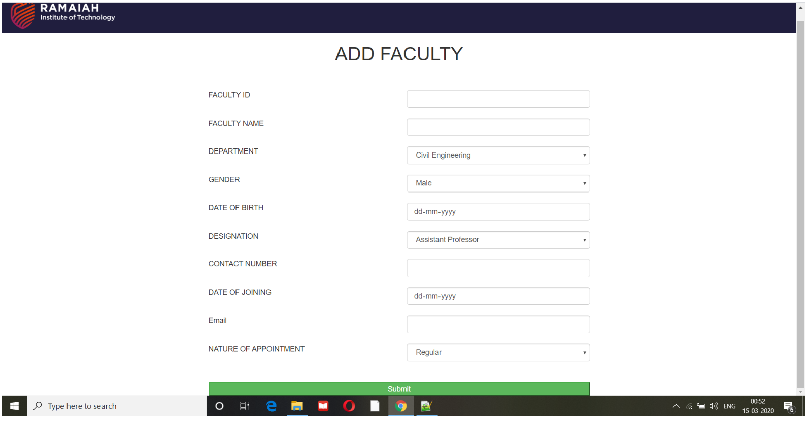

\*Add Faculty details using this page

\* After entering fields if press submit button details will be saved in the database

3.FACULTY PROFILE TABLE

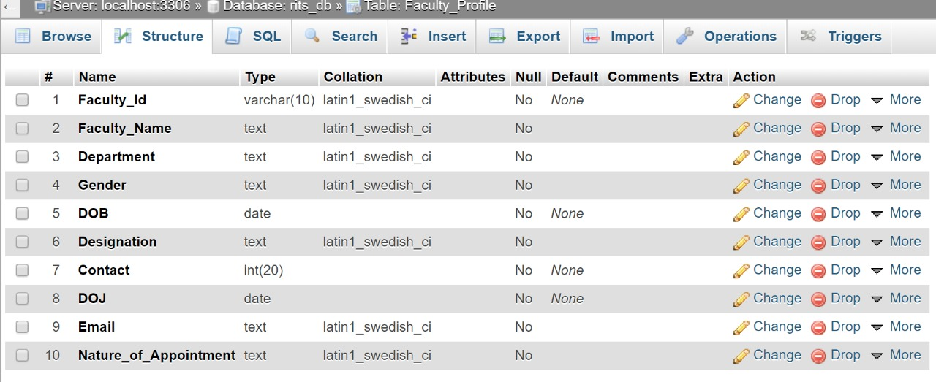

\*Faculty Profile table created in the database as shown